Endless Laptop

Student Orientation

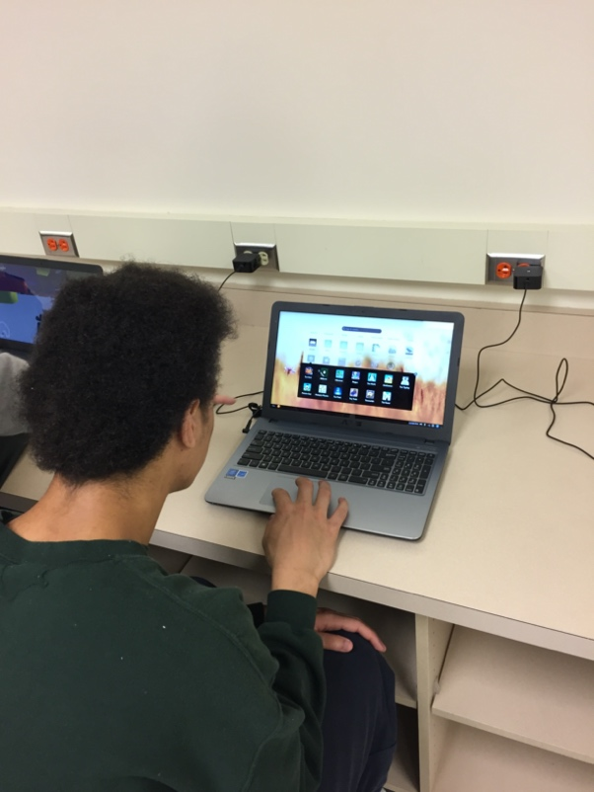

|  |  |
| --- | --- |
| Materials Needed | **Endless Training Laptop for each participant.**  **TV screen or overhead projector.**  **Endless Laptop / Docking Station attached to projection screen.**  **Handouts – Endless Laptop Users Agreement** |
| Goal | The goal of this training is to provide students with a basic orientation to the Endless OS laptop. Students can learn about content and how the laptop operates. |
| Objectives | * Presentation of Endless Laptop * Develop student responsibility – User Agreement * Understand content, applications and what the learning potential is inside and outside of the classroom. * Promote self-directed learning and discovery. |
| 1. Introduction   (5 mins) | Understanding the guidelines of the User Agreement. (Respect equipment / handling, no food or drink around devices, awareness of your privacy – by not sharing your password or laptop.)  Explain what to expect from future use of the laptop. This initiative is to increase the student’s ability for self-expression, access to digital content and a pathway for higher education and career building skills. |
| 2. Presentation on User Agreement and youth sign off. (30 mins) | Hand out and go through “User Agreement”. Students to sign off on the agreement before laptop is used. |
| 3. Hand out - Endless OS Laptops  (5 mins) | Hand out the Endless OS Laptops as the participants turn in their signed user agreements. |
| 4. Navigate Hardware (5 mins) | * Show where to find the power button (top right corner) and demonstrate how to turn on the device. * Point to the earphone jack on the left side of the device. Explain they will be allowed use earbuds or headphones. There is no audio speaker function on the laptop. * Explain that the power plug is the only thing that should be inserted into the power jack and this should be carefully. At some locations there will be charging stations. * Explain the touch pad and how it works by sliding your finger across and touch tapping the pad. You can also press in on the pad to select. However, it is preferred to tap unless dragging an object then you will need to press. |
| 5. Sign on to the Endless OS Laptop (5 mins) | Have the students sign on with their “Training Sign On” Example: **student** (The password to this sign on is the same as the sign on name - **student**. It is all lower case.) |
| 6. Rachel App (10 mins) | Have the participants open the Rachel app here you will walk through briefly on the sections provided. Allow students a few minutes to explore content. |
| 7. Virtual School or Kahn Academy (10 mins) | Have the participants open the Virtual School App explain the benefits and opportunity they have to be able to explore this area. Give them a few minutes to do so. |
| 8. Work Section (5 mins) | Here you will give students a few minutes to see how to stack several apps into a folder called work to help keep things organized. There will be more classes that will give them the opportunity to work in this area. |
| 9. Assignment (10 mins) | Have the students type “Writer” in the search bar, next click on the result “Libre Office” Students can type at least one paragraph “What benefits they see in having a laptop for regular use?”  Instructions:   * Name and number at the top left corner of page * Type paragraph * Save document “Save as” * Name the document” Assignment1”   Explore the App Store. Demonstrate that students can choose applications to put on their desktops. Explain that not all downloads are available – due to size restrictions. Students can put a new application on their desktop. |
| 10. Shutdown (1 min) | Show how to turn off the Endless OS Laptop by selecting the circle in the lower right hand side of the monitor then select “Power Off” |

A spreadsheet is available to track each laptop with the assigned student. There will be tracking of each individual youth ID and their password. The spreadsheet also identifies the Administrator of that youth’s laptop and their Admin. ID and password.