4th of July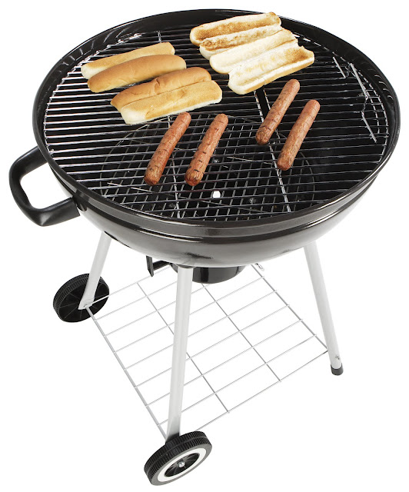

**Neighborhood Block Party**

**You’ve got burgers. We’ve got buns.**

Come grill with your neighbors before it gets too hot, dog.

WHEN

**Monday, July 4th**

**11:00 AM until 11:00 PM**

Rain or shine

WHERE

**Buzzy Pond Way**

Parking on Blair Street

LIVE MUSIC by Bernard and the Black Books

FIREWORKS by Tim & Daisy's dad



SWIMMING @ BUZZY POND PARK

For more info, contact Ray: [raymond.gilsig@gmail.com](mailto:raymond.gilsig@gmail.com)